ORIGINAL Project Title: Infrared Transmission
EDITED Project Title: Infrared LED
Link: https://wiki.microduino.cc/index.php/Infrared_transmission
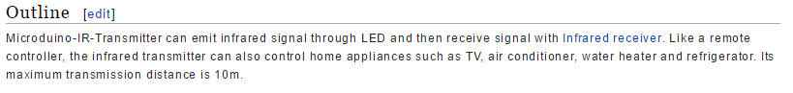
ORIGINAL:
Microduino-IR-Transmitter can emit infrared signal through LED and then receive signal with Infrared receiver. Like a remote controller, the infrared transmitter can also control home appliances such as TV, air conditioner, water heater and refrigerator. Its maximum transmission distance is 10m.
EDIT:
The Microduino IR LED can emit infrared signals just like a remote control. Couple this with an infrared receiver and you can control projects from a distance. The maximum transmission distance for the emitter is 10 meters.

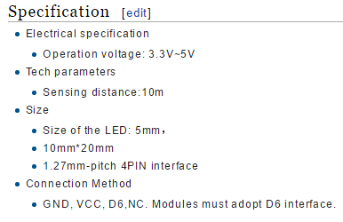
ORIGINAL:
- Electrical specification
  - Operation voltage: 3.3V~5V
- Tech parameters
  - Sensing distance:10m
- Size
  - Size of the LED: 5mm，
  - 10mm*20mm
  - 1.27mm-pitch 4PIN interface
- Connection Method
  - GND, VCC, D6,NC. Modules must adopt D6 interface.

EDIT:
- Electrical Specifications
  - Operation Voltage: 3.3-5V
  - Output Device
- Technical Specifications
  - Emitting Distance: 10 meters
  - Emitting Angle: 25 degrees
  - Wavelength: 940nm
- Dimensions
  - LED: 5mm
  - Sensor Board: 20mm x 10mm
  - Interface: 4-Pin, 1.27mm pitch
- Interface
  - Pins: D6 (on Hub), VCC (power), GND (ground) and NC (Not Connected)
  - NOTE: To emit at the proper frequency for remote control (38KHz), the sensor must be connected to pin D6 on the Sensor Hub

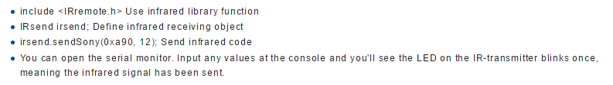
ORIGINAL:
- include <IRremote.h> Use infrared library function
- IRsend irsend; Define infrared receiving object
- irsend.sendSony(0xa90, 12); Send infrared code
- You can open the serial monitor. Input any values at the console and you'll see the LED on the IR-transmitter blinks once, meaning the infrared signal has been sent.

EDIT:
[ADD Section Title: ] Program Explanation
- #include <IRremote.h> - Imports the IRremote library and allows you to use all functions.
- IRsend irsend; – Declares an object for the infrared transmitter to use IR functions.
- Irsend.sendSony(0xa90, 12); - Sends an infrared code using a Sony remote protocol.
- Once you open the Serial Monitor, you can input any values into the console. The LED on the transmitter will blink once the infrared signal has been sent.

